Data processing
- Ensure wheels are appropriately named and that .wls files are being saved as these will be what is needed to export to a .csv
- Open Wheel Manager. Navigate to File -> Export to export
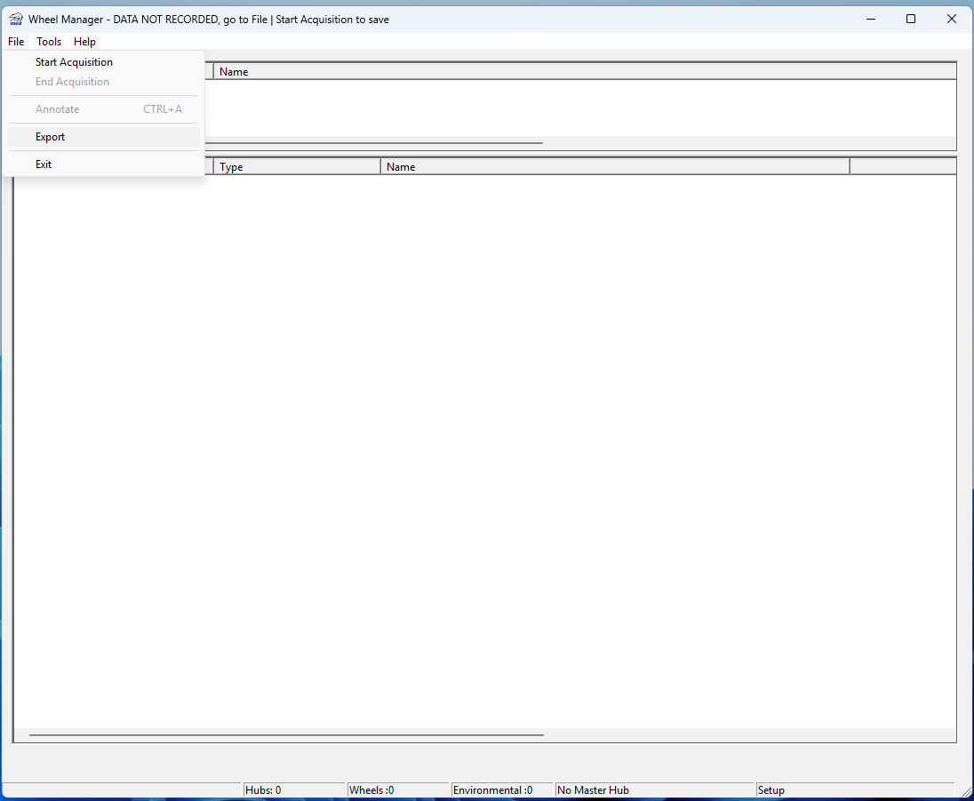
- Select each .wls file that you wish to process
  - It will automatically fill in the start and end date
  - Have Date/Time Column, revolutions, sensor names, row labels, column labels, bin size = 1min, all wheel sensors you want analyzed (check box underneath “Wheel Sensor” selects all of them for you
    - This makes each row # revolutions at minute intervals and each column a subject
  - DO NOT have heading or “output nulls as zero” selected
    - Selecting header meses up .csv layout and it nulls are zeros then the code cannot tell when there was no data being transmitted (nulls)
- Lastly, make sure all subjects are present and in same order as the first .csv that is uploaded. If not, the code will error as it cannot analyze out of order or missing subjects. You may need to add missing subjects to files that need them or reorder those files. Alternatively, you could run cohorts separately if a group has already been collected too.
  - Ex: if all subjects are 1, 2, 3, 4, 5 in first file. Files ordered 1, 3, 4, 5 or 2, 1, 3, 4, 5 would error
  - Ex: if first file is 1, 2, 3 and then 4,5 are added later on then on the first file you can add 4 and 5 with all 0s for revolutions

Example of everything that should be selected:
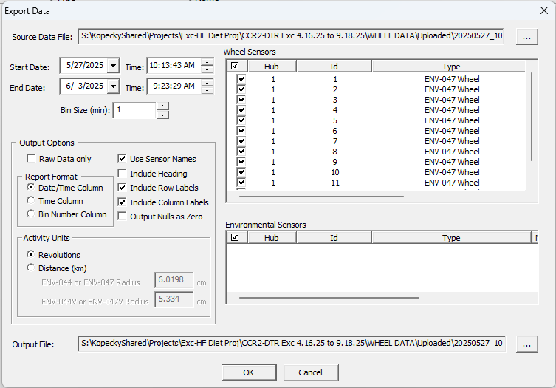

Make sure to save as .CSV!!!!
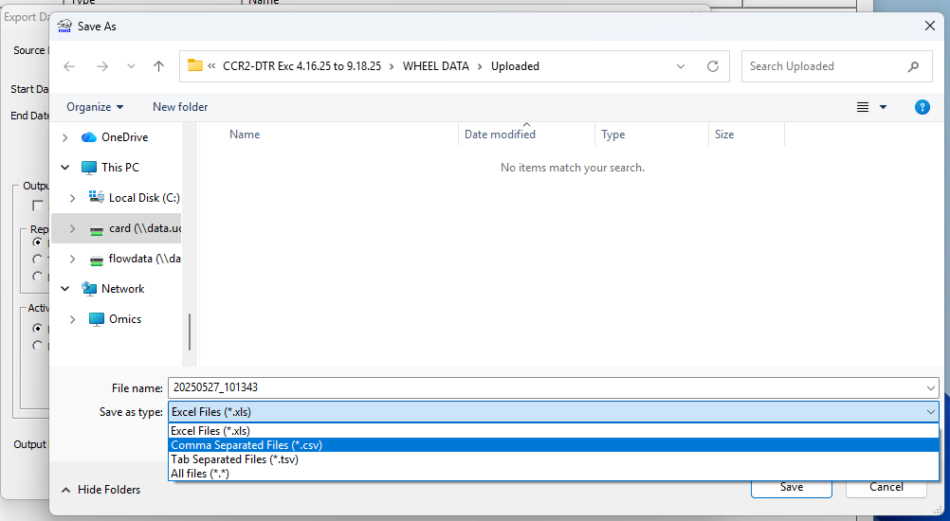

Good CSV – code will run beautifully
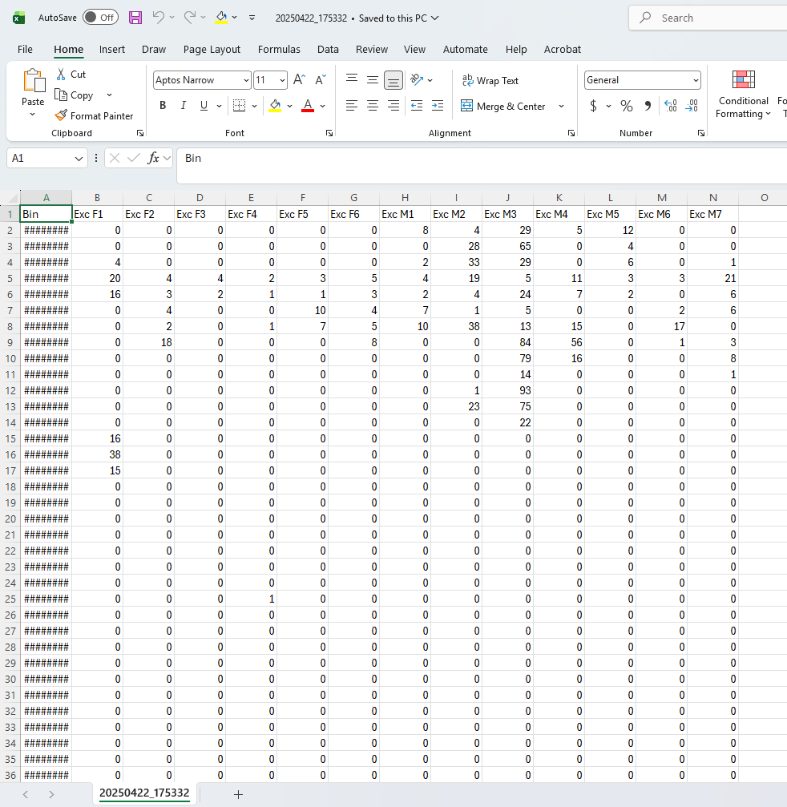
Bad CSV – code will not run
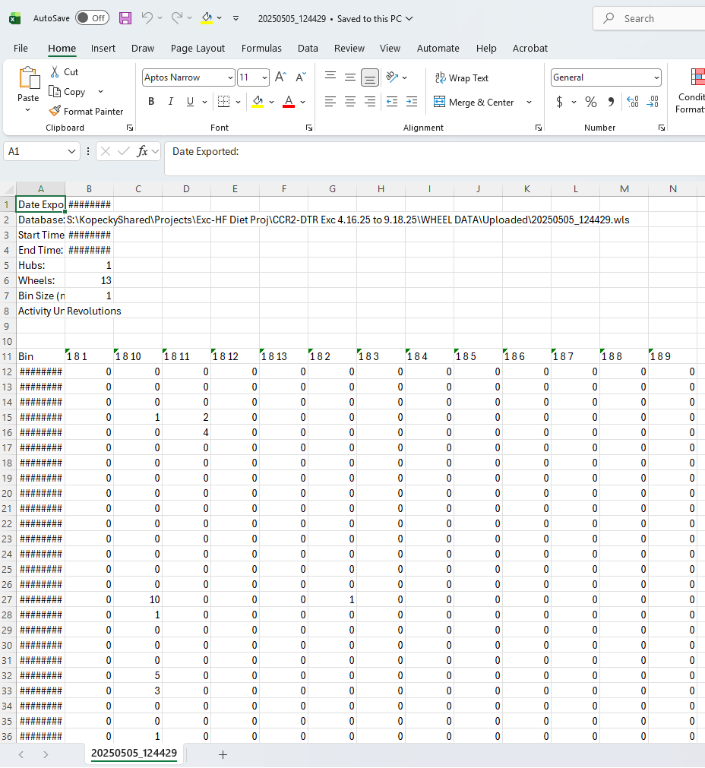

- You are now ready to analyze the wheel data. Continue below

Code Analysis
- Download MATLAB through CU Anschutz
- Download the Exercise wheel MATLAB script
  - https://github.com/g6bonnici/ExerciseWheelTracking
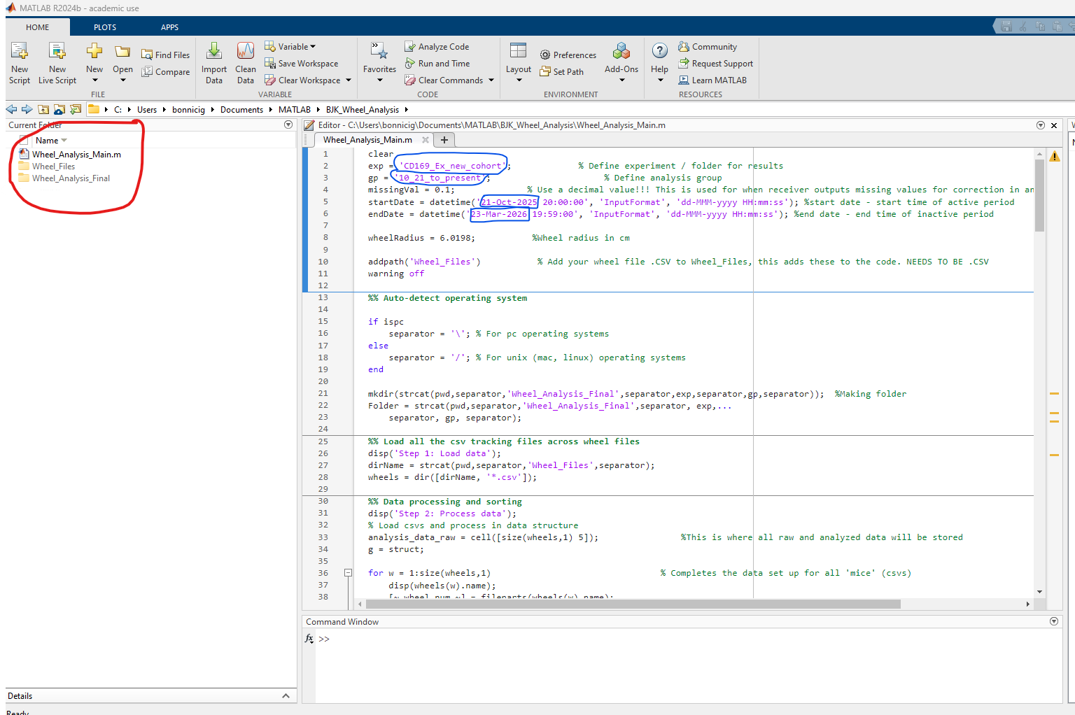
- Make a Wheel_Files and Wheel_Analysis_Final folder as seen below (red). Make sure these names match exactly!!!!!!!!!!!!!!!!
- (Blue) Name your experiment for exp =’’ , Name the analysis group for gp = ‘’ , Enter the start and end date but keep the start time 20:00:00 and end time 19:59:00
  - Don’t change missingVal
  - Don’t change wheelRadius
    - Unless of course we get new wheels

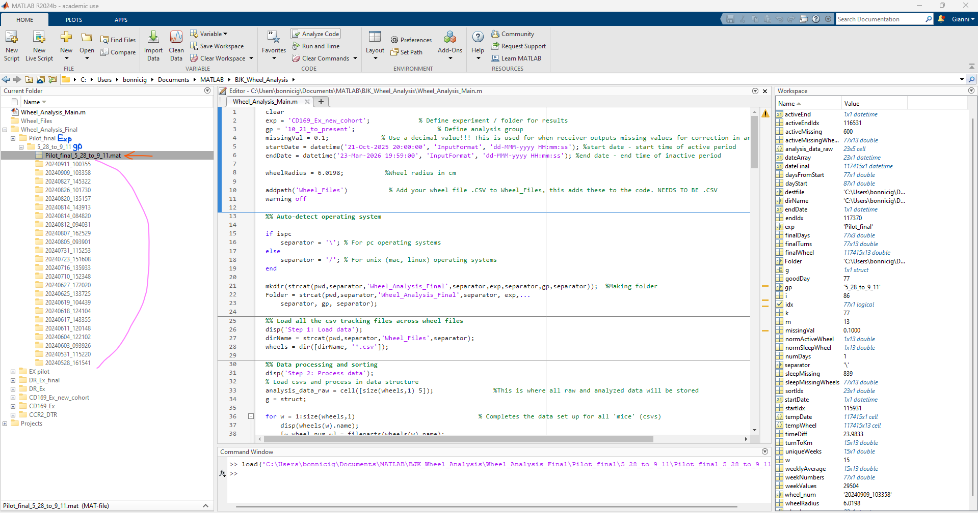
- In Wheel_Analysis_Final, exp is a main folder and gp being subfolder (both in blue)
  - The data produced from code will be stored in a .mat (orange)
  - After running the code, the information from .mat will automatically appear in workspace
  - Double clicking the stored file (orange) will allow it to populate the data (in the workspace) without rerunning the whole code
    - Workspace is on the right
    - The files the are included in the .mat are the folders below (pink)
  - Ignore the “Projects” folder in future screenshots
    - This is NOT applicable to anything
- Make sure to add folders and subfolders to path (red arrow) by right clicking on folder
  - The folder text should now be more visible than it was before

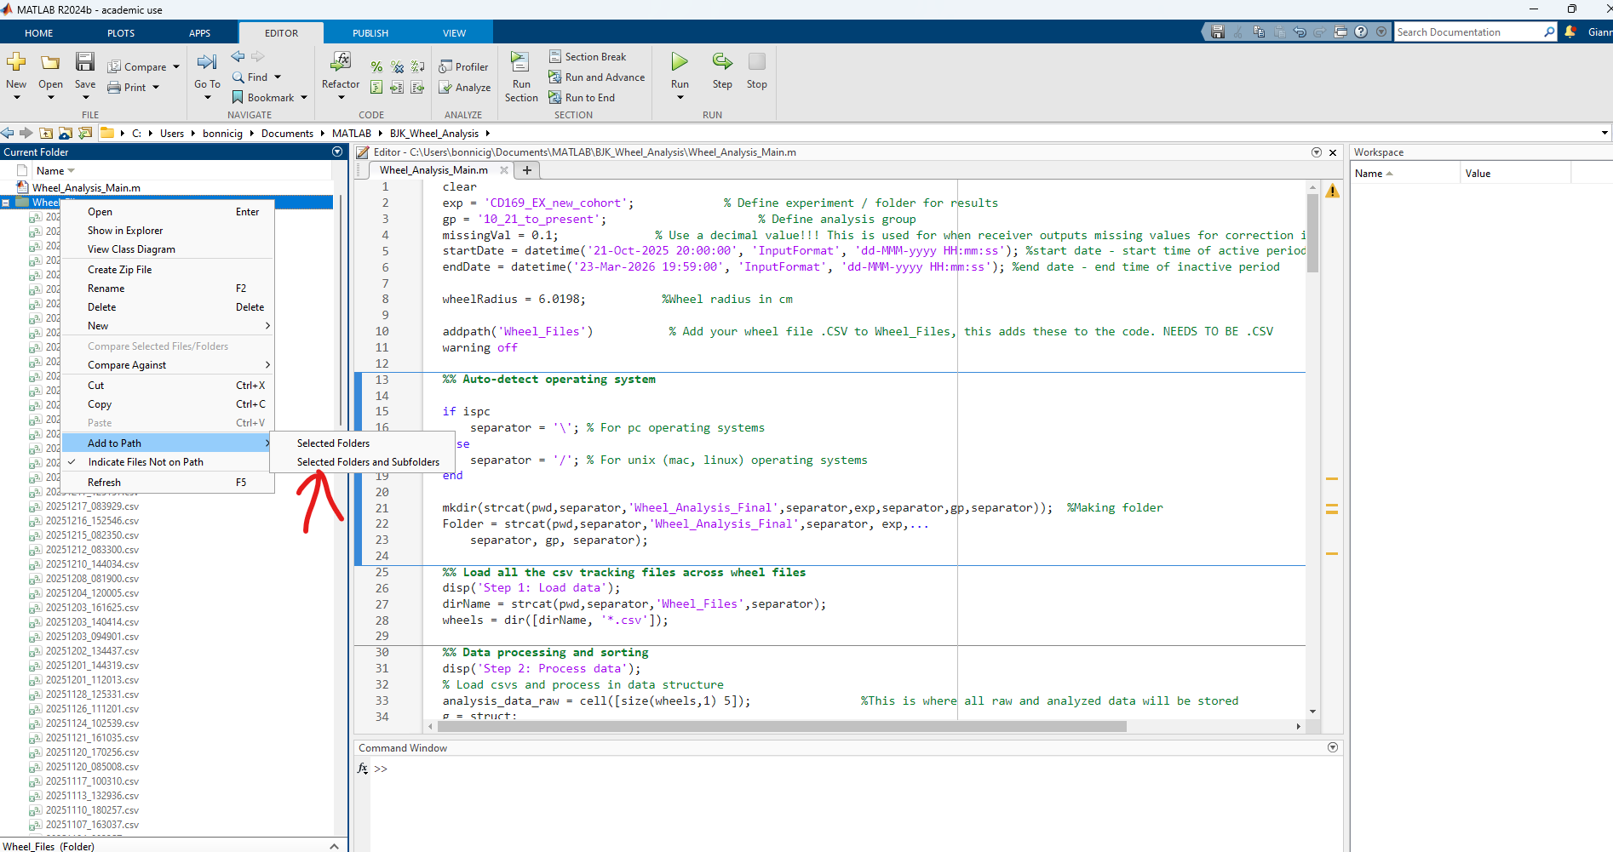
- Drag and drop the .csv files into Wheel_Files folder (blue arrow) and now the code can be run (red arrow)
  - Notice all of the .csv files in Wheel_Folder. Files automatically labled year, month, day, time by the program
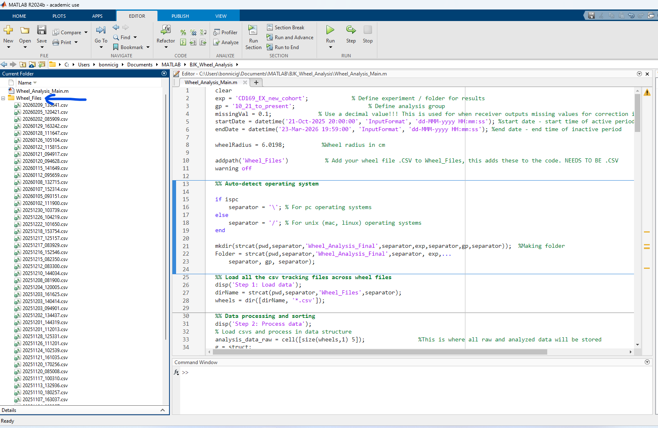
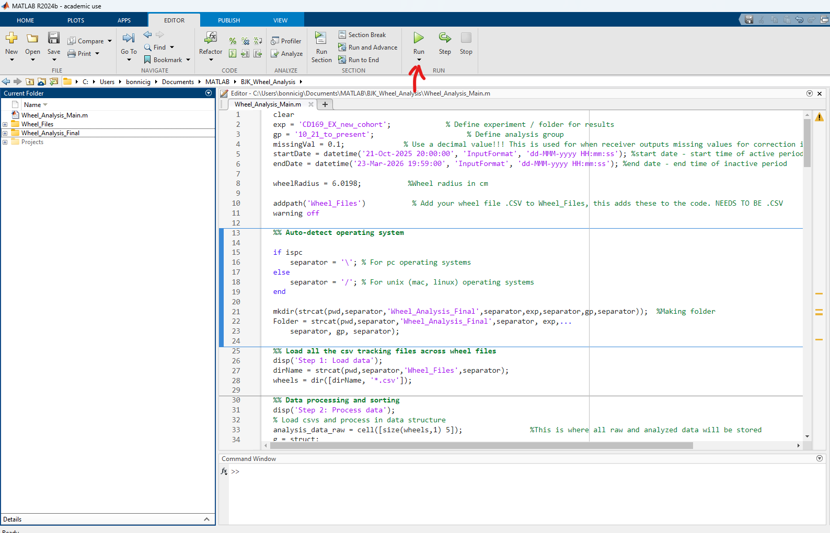
- Once you hit run text will start appearing in the command window (blue circle)
  - If you get the error indicated by the red arrow then you need to double check that the .csvs have all the same samples in them in the same position. If not, add in the missing sample (input all 0s for the wheel) or rearrange the samples.

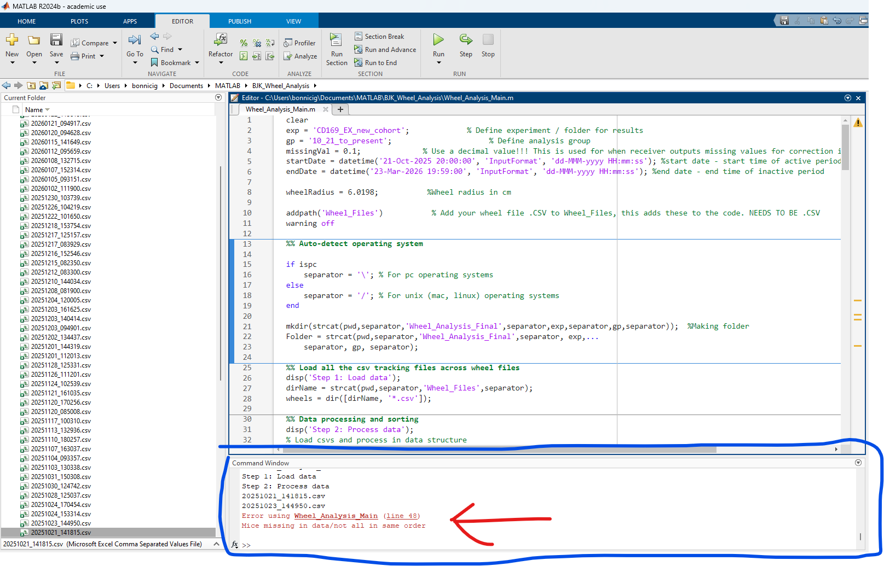
- Below is what it looks like if the code runs in full from the command window
  - Step 1 is the code loading in the data to MATLAB (telling matlab how to find the .csv in the Wheel_Files folder
  - Step 2 is processing the data in each .csv into a MATLAB cell to be analyzed which gives the calculation of “finalTurns” which is the total amount of turns per week for each sample (discussed later)
  - Step 3 is processing finalTurns into km and appropriately normalizing for how many days that data has been recorded in that week to the final calculation of “turnToKm”
  - Step 4 indicates that the data is being saved to MATLAB as a .mat file in the Wheel_Analysis_Final folder under the designated exp -> gp folder.
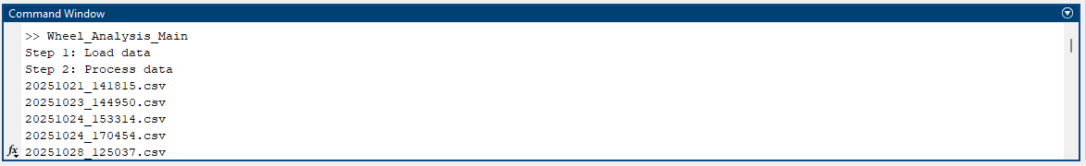
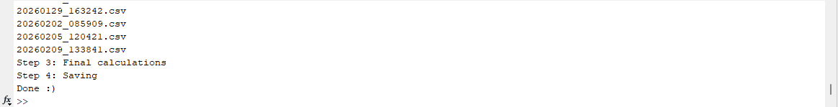
- All of the variables are outputted in the “Workspace” area (red circle)
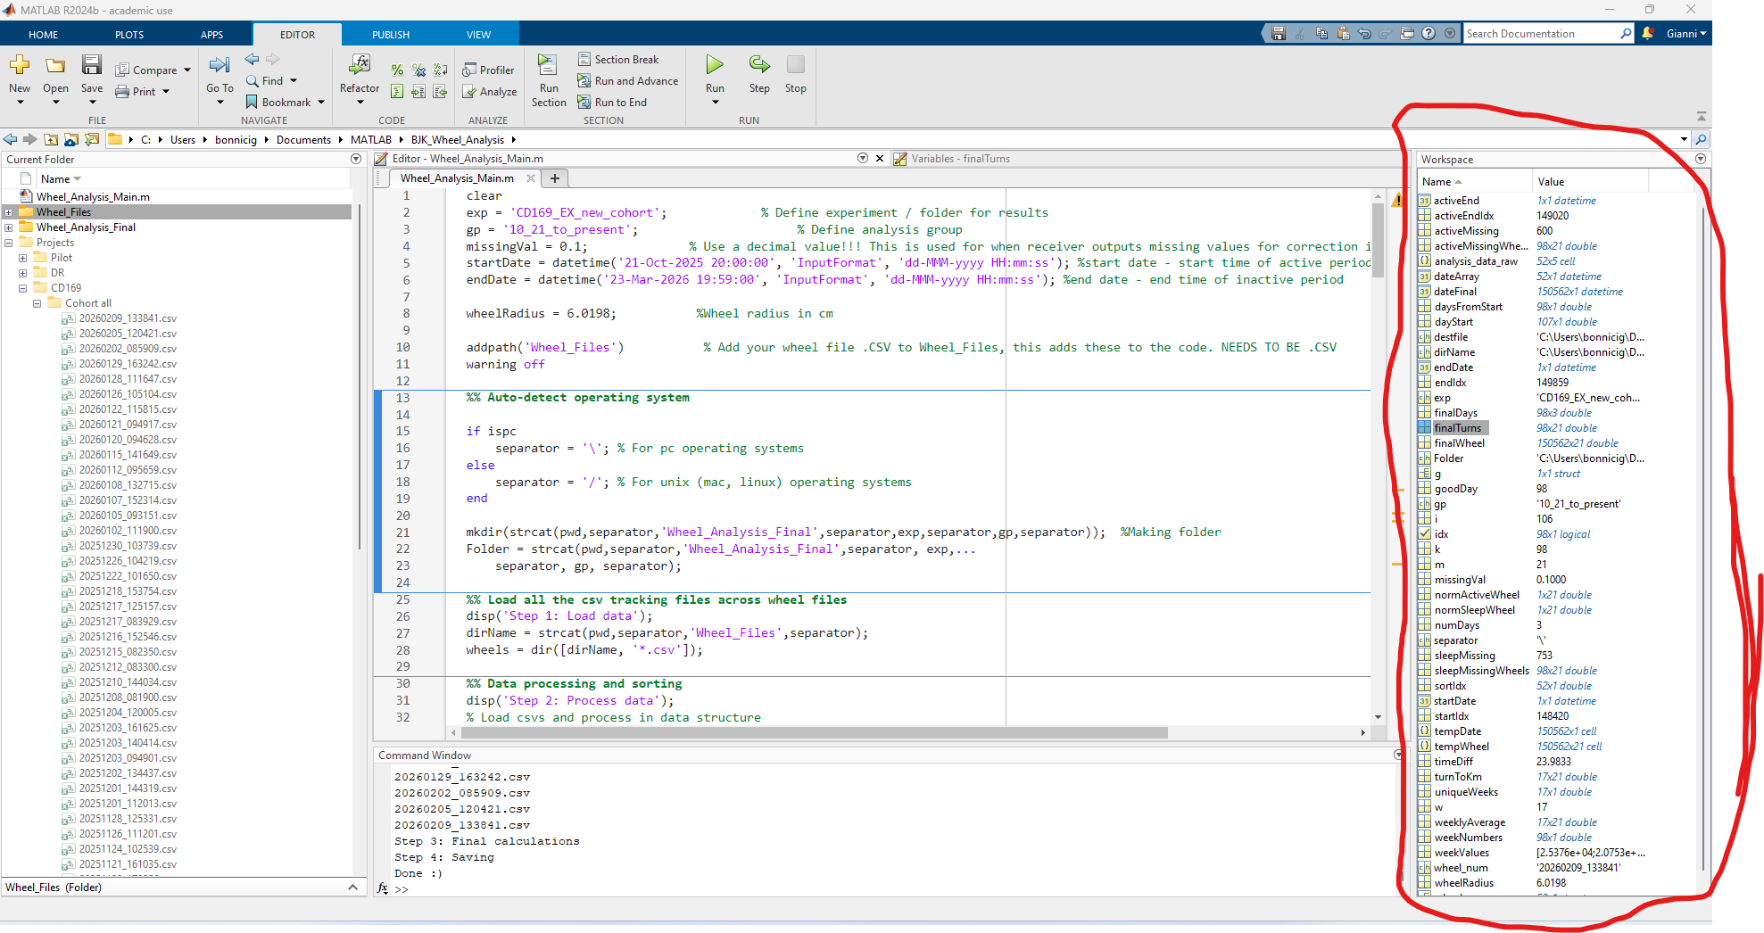

- Here is a brief overview of the three most important files here:
  - analysis_data_raw (grey arrow) is where all of the raw data is placed into a cell prior to any data analysis occurs.
    - Each row represents a .csv file
    - Column 1 is what the first row of the .csv file is (should be the labels, good to check to make sure everything is in the order you believe it is in. code auto checks to make sure this order is the same for all files and errors if not)
    - Column 2 is the time column from .csv
    - Column 3 is the wheel revolutions per unit time for all mice in that file
    - Column 4 is the start date/time and column 5 is the end date/time for that file
      - Allows code to sort and analyze the files in chronological order
  - finalTurns (blue arrow) is where all of the revolutions per week for all mice is located
    - This is normalized based on separate inactive (10h) and active (14h) periods. If mice are on a different L-D cycle this will need to be modified accordingly (yellow arrow – line 85; change 10 to whatever active period is).
  - turnToKm (red arrow) is where the final data will be stored. Each row is a week and each column is a sample with the samples being in order as shown in analysis_data_raw column 1.
    - Each week has the revolutions summed and then averaged based on the number of days where running was tracked.
      - If there is a poor connection day or running was an outlier then all running that day can be made 0 manually in .csv (needs to be from start of active to inactive – 20:00:00 to 19:59:00 of next day) – this prevents this oulier day from skewing running in normalization
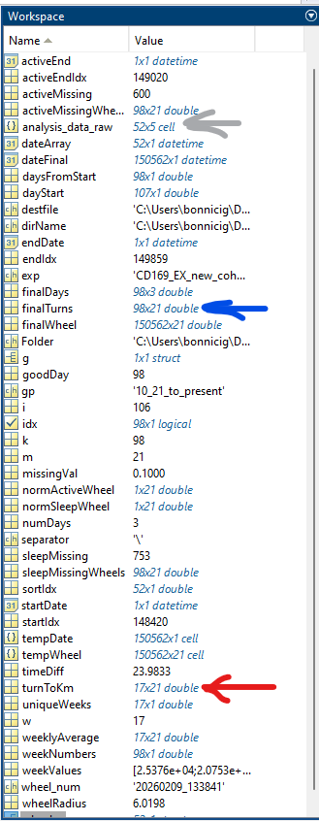
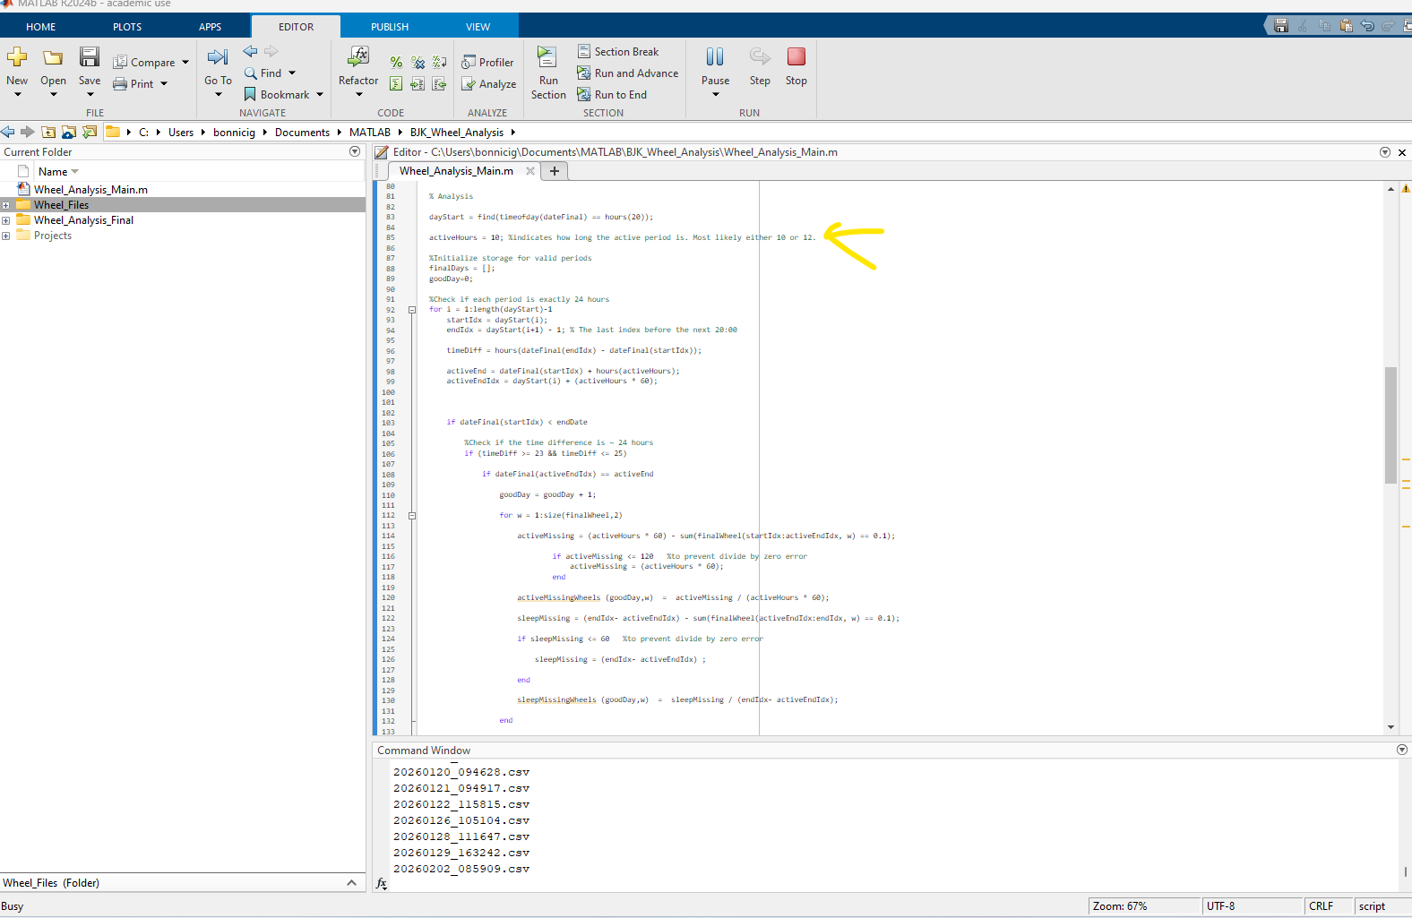
- Double clicking on turnToKm opens it into a “variables” tab where the data can be copy and pasted into Prism or another analysis software (data is in kilometers now).
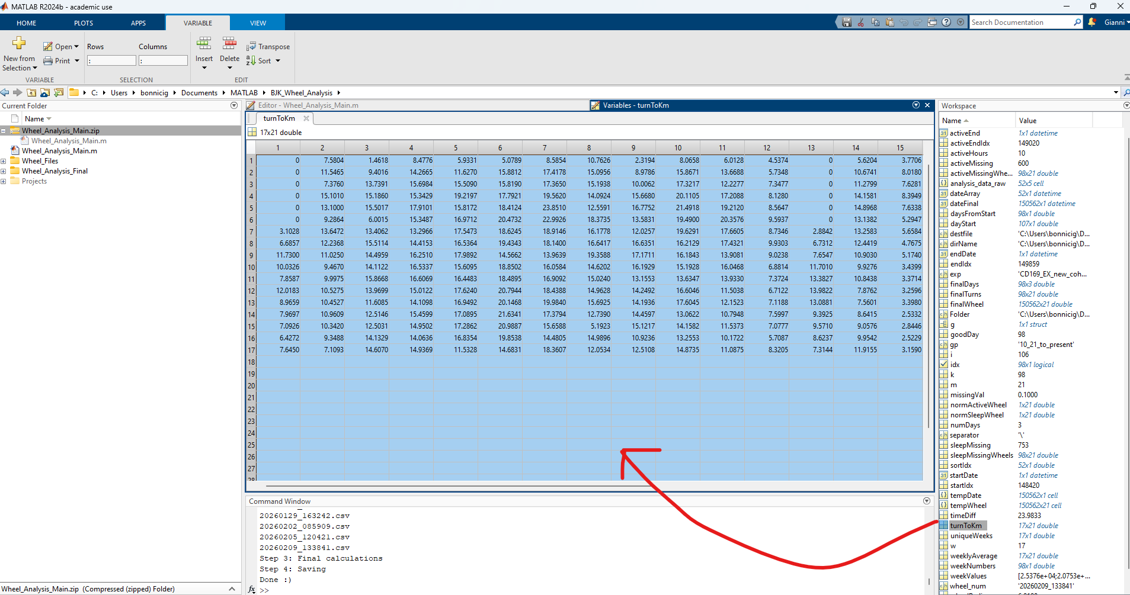
- As the code says Done :)

